For Computer Shop Management System

Version 1.0

Revision History

|  |  |  |  |
| --- | --- | --- | --- |
| **Date** | **Version** | **Description** | **Author** |
| 7/12/2019 | 1.0 | details | Phạm Thị Hồng Trang |
|  |  |  |  |
|  |  |  |  |
|  |  |  |  |

Table of Contents

1. Introduction 4

1.1 Purpose 4

1.2 Scope 4

1.3 Definitions, Acronyms, and Abbreviations 4

1.4 References 4

1.5 Overview 4

2. Overall Description 5

2.1 Use-Case Model Survey 5

2.2 Use-Case Reports 5,6

2.3 Supplementary Requirements 6

3. Supportting Information 5

# Introduction

Buying or viewing the available computer at computer shop is currently done manually where the customers have to go to the shop to check the available computers. This may become a waste of time if the customer’s desired computer is unavailable at the computer. And it is inconvenient for the customers from remote areas to buy computer. In addition, the employees of our computer shop may find difficulty in managing the computer in the computer shop. Therefore, we have decided to establish a Computer Shop System. This system would be used by customers to check the availability of the computers and buy the computers, and by the employees to sell the computer and update the databases. The purpose of this document is to analyze and elaborate on the high-level needs and features of the Computer Shop System. It focuses on the capabilities and facilities provided by a shop.

## Purpose

The purpose of Software Requirements Specification document is to describe the external behavior of the Computer Shop System. Requirements Specification defines and describes the operations, interfaces, performance, and quality assurance requirements of the Computer Shop System. The document also describes the nonfunctional requirements such as the user interfaces. It also describes the design constraints that are to be considered when the system is to be designed, and other factors necessary to provide a complete and comprehensive description of the requirements for the software. The Supplementary Specification captures the complete software requirements for the system, or a portion of the system. Requirements described in this document are derived from the Vision Document prepared for the Computer Shop System.

## Scope

The Software Requirements Specification captures all the requirements in a single document. The Computer Shop System that is to be developed provides the customers and the employees of the computer shop with computer information, online shopping of computer and many other facilities.

## Definitions, Acronyms, and Abbreviations

HANU-Ha Noi University.

## References

TBD.

## Overview

The Computer Shop Requirements Specification will provide a detailed description of the computer shop system. This document will provide the outline of the requirements, overview of the characteristics and constraints of the system.

# Overall Description

The overall description of our project can be stated as creating and managing the database, developing a friendly user interface to manipulate the computer shop database.

## Use-Case Model Survey

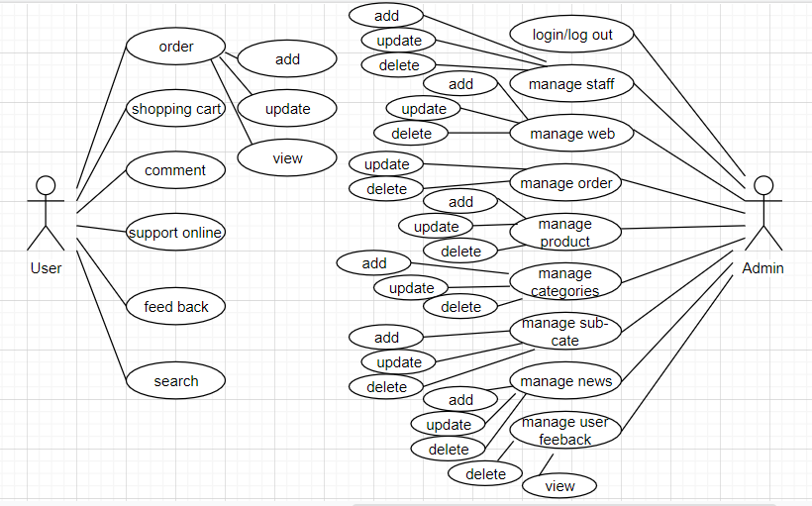

## Use-Case Reports

**2.2.1 Shopping cart**

The guesses after signing up to become customer of computer shop can add computer to shopping cart and see all views about total price by clicking in shopping cart.

**2.2.2 Order computer**

After see all information in the shopping cart which include name of computer, color, quantity, price. Customer to click in payment to complete the process of order in the compute shop.

**2.2.3 Comment**

Customer can have some comments after buying computer in our computer shop.

**2.2.4 Support Online**

Customer can contact online to get fast helps from our staff of computer shop.

**2.2.5 Search**

Customer can search to find computer faster, save time in computer shop.

**2.2.6 Give feedback**

After receive computer from CT Computer, customer can send feedback about quality of products also of our services.

**2.2.7 Manage Category**

Admin can divide computer in different categories.

**2.2.8 Manage product**

This function belongs to admin who control all changes of computer shop. They can add, update or delete a computer.

**2.2.9 Manage news**

Admin can create news about computer shop, promotion or update this news or also delete it.

**2.2.10 Manage order**

Admin is the person who ca update information of order if it contains some errors or delete it if it is canceled.

**2.2.11 Mange customer**

Admin can remove some customer if they have some impolite in comment section to ensure about quality of computer shop.

**2.2.12 Manage staff**

Admin can add information of a new staff, update it and also delete staff out of computer shop system.

**2.2.13 Manage Web**

Admin control all banner of computer shop in here

**2.2.14 Manage Sub-Category**

In computer shop, there are many different computers so admin divide in small part to control easier.

**2.2.15 Manage customer feedback**

Admin can view feedback of customer in detail and also can delete impolite feedback.

## Supplementary Requirements

**2.3.1 Interface requirement**

- Clear, convenient and easy to use

- Interface includes different tabs according to user role types determined by admin at the authentication phase.

**2.3.2 License**

License belongs to cosmetic shop that purchased the Computer Shop System from

Group - class 6C17 HANU and agreed on the maintenance contract.

**2.3.3 Legal, Copyright, and Other Notices**

2018 Copyright to Group – CT Computer HANU. All rights reserved.

# Supporting Information

CT Computer HANU